**BPL Management System 01**

**Business and System summary**

BPL Management System database has been developed which can be use for business purpose. This database can be use for electronic commerce system which is simple & secure for users. This system will provide information about BPL where anyone can know about the BPL tournament player’s information, club information, match information, sponsor’s information, jersey information, match details information and venue details information from website. In this database management system it can manages its entire club’s data, player data, match data, stadium data, sponsor data & others necessary data. Management can add, delete or modify their data. It is very difficult to see any data which kept in different folder. By this database management system management can see any data by a simple query.

**Overview of the Business Environment and Project Objectives**

* **Business Environment**

The project BPL Management System has been developed based on the database. There are many software where we keep our database records. We are using ORACLE 10g Express Edition to keep our database records which is one of the best & easiest software in the world. Oracle applications comprise business software of the Oracle Corporation. Oracle’s technological advantage has helped us to changing the business environment & market competition. We have successfully developed a secure platform for our database project through this software.

* **Project Objectives**

1. To view the details of a club
2. To view the details of players
3. Owners can know about players
4. To keep all data of venue & matches in a database
5. To view all data of a tournament easily to the viewers

**02**

**Technical summarization of our developed database**

At first I got knowledge about database management system from our classes. Then I got a project for Introduction to Database course. Then I design an ER diagram on Cricket Tournament management System (Bangladesh Premier League) from the knowledge I got earlier and normalized the ER diagram up to 3rd Normal Form. Using that normalized form I obtained a relationship table (Schema) with data type and used Data Definition Language (DDL) to create table with their columns and data type. Then I collected values from espncricinfo.com and inserted the values into the table to get the desire database System.

**Justification of the project objectives and how it will support the business**

It is easily ensuring the data can be kept easily with data redundancy. There are 8 tables which is designed to keep all the data and show by a simple query as we done it in the below part. There is no need to keep data in folders. I have justified it in the below parts how it works and how it meets the requirements. Now come to the business point, it meets the business requirements by showing the data to viewers easily. This database can be used in website to view the details of the tournaments. Franchise can see their desired player details like name, age, price, playing role etc.

**NORMALIZATION 04**

**Has-1**

|  |  |  |  |  |  |
| --- | --- | --- | --- | --- | --- |
| **Id** | Name | Owner | **S_Id** | S_Name | Amount |

Id, S_Id Name, Owner, S_Name, Amount

Id Name, Owner

S_Id S_Name, Amount

**1NF**

|  |  |  |  |  |  |
| --- | --- | --- | --- | --- | --- |
| **Id** | Name | Owner | **S_Id** | S_Name | Amount |

**2NF**

**Club**

|  |  |  |
| --- | --- | --- |
| **Id** | Name | Owner |

**Sponsor**

|  |  |  |  |
| --- | --- | --- | --- |
| **S_Id** | S_Name | Amount | **Id** |

**Belongs**

|  |  |  |  |  |  |
| --- | --- | --- | --- | --- | --- |
| **Id** | Name | Owner | **P_Id** | P_name | Age |
| Playing_Role | Batting_Style | Bowling_style | Type | Price |

Id, P_Id Name, Owner, P_Name, age, Playing_role, Batting_style, Bowling_Style, Bowling_style, type,price **05**

Id Name, Owner

P_Id P_name, Age, Playing_role, Batting_style, Bowling_style,

Type, Price

**1NF**

|  |  |  |  |  |  |
| --- | --- | --- | --- | --- | --- |
| **Id** | Name | Owner | **P_Id** | P_name | Age |
| Playing_Role | Batting_Style | Bowling_style | Type | Price |

**2NF**

**Club**

|  |  |  |
| --- | --- | --- |
| **Id** | Name | Owner |

**Player**

|  |  |  |  |  |
| --- | --- | --- | --- | --- |
| **P_Id** | P_name | Age | Playing_Role | Batting_style |
| Bowling_style | Type | Price | **Id** |

**Gives**

|  |  |  |  |  |
| --- | --- | --- | --- | --- |
| **S_Id** | S_name | Amount | **J_no** | Colour |

S_Id, J_no S_name, Amount, Colour

S_Id S_name, Amount

J_no Colour **06**

**1NF**

|  |  |  |  |  |
| --- | --- | --- | --- | --- |
| **S_Id** | S_name | Amount | **J_no** | Colour |

**2NF**

**Sponsor**

|  |  |  |  |
| --- | --- | --- | --- |
| **S_Id** | S_name | Amount | **J_no** |

**Joursey**

|  |  |
| --- | --- |
| **J_no** | Colour |

**Has-2**

|  |  |  |  |  |
| --- | --- | --- | --- | --- |
| **P_Id** | P_name | Age | Playing_Role | Batting_style |
| Bowling_style | Type | Price | **J_no** | Colour |

P_Id, J_no P_name, Age, Batting_style, Playing_Role, Type, Bowling_style, Price, Colour

P_Id P_name, Age, Batting_style, Playing_role, type,

Bowling_style, Price.

J_no Colour

**1NF**

|  |  |  |  |  |
| --- | --- | --- | --- | --- |
| **P_Id** | P_name | Age | Playing_Role | Batting_style |
| Bowling_style | Type | Price | **J_no** | Colour |

**2NF**

**Player**

|  |  |  |  |  |
| --- | --- | --- | --- | --- |
| **P_Id** | P_name | Age | Playing_Role | Batting_style |
| Bowling_style | Type | Price | **J_no** |

**Joursey**

|  |  |
| --- | --- |
| **J_no** | Colour |

**Play**

|  |  |  |  |  |  |  |
| --- | --- | --- | --- | --- | --- | --- |
| **Id** | Name | Owner | **M_Id** | M_type | Amp | Mom |
| Over | Wicket | Run | Team_A | Team_B |

Id, M_Id Name, Owner, M_id, M_type, Amp, Mom, Over,

Wicket, Run, Team_A, Team_B

Id Name, Owner.

M_Id M_type, Amp, Mom, Over, Wicket, Run, Team_A, Team_B

**1NF**

|  |  |  |  |  |  |  |
| --- | --- | --- | --- | --- | --- | --- |
| **Id** | Name | Owner | **M_Id** | M_type | Amp | Mom |
| Over | Wicket | Run | Team_A | Team_B |

**2NF 08**

**Club**

|  |  |  |
| --- | --- | --- |
| **Id** | Name | Owner |

**Match**

|  |  |  |  |  |  |  |
| --- | --- | --- | --- | --- | --- | --- |
| **M_Id** | M_type | Amp | Mom | Over | Wicket | Run |
| Team_A | Team_B | **Id** |

**Playing**

|  |  |  |  |  |  |
| --- | --- | --- | --- | --- | --- |
| **Std_Id** | Std_name | Location | Capacity | **M_Id** | M_type |
| Amp | Run | Team_A | Team_B | Over | Mom |

Std_Id, M_Id Std_name, Location, Capacity

M_type, Amp, Run, Team_A, Team_B, Over, Mom

Std_Id Std_name, Location, Capacity

M_Id M_type, Amp, Run, Team_A, Team_B, Over, Mom

**1NF**

|  |  |  |  |  |  |
| --- | --- | --- | --- | --- | --- |
| **Std_Id** | Std_name | Location | Capacity | **M_Id** | M_type |
| Amp | Run | Team_A | Team_B | Over | Mom |

**2NF**

**Stadium 09**

|  |  |  |  |
| --- | --- | --- | --- |
| **Std_Id** | Std_name | Location | Capacity |

**Match**

|  |  |  |  |  |  |
| --- | --- | --- | --- | --- | --- |
| **Std_Id** | Std_name | Location | Capacity | **M_Id** | M_type |
| Amp | Run | Team_A | Team_B | Over | Mom |

**Venue_Details**

|  |  |
| --- | --- |
| **M_Id** | **Std_Id** |

**3NF**

**Match_summary**

|  |  |  |  |
| --- | --- | --- | --- |
| **Id** | Run | Wicket | **M_Id** |

**Relationship Diagram 10**

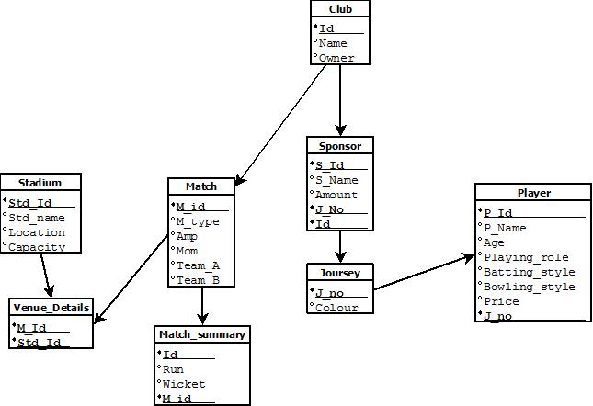

CREATE TABLE Club(

Id NUMBER(6),

Name VARCHAR2(25),

Owner VARCHAR2(30),

CONSTRAINT Club_Id_PK PRIMARY KEY (Id)

);

--

CREATE TABLE Player(

P_Id NUMBER(6),

**11**

P_Name VARCHAR2(20),

Age NUMBER(20),

Playing_role VARCHAR2(30),

Batting_style VARCHAR2(30),

Bowling_style VARCHAR2(30),

Price NUMBER(10),

J_No NUMBER(6),

CONSTRAINT Player_Id_PK PRIMARY KEY (P_Id),

CONSTRAINT Player_JNo_FK FOREIGN KEY (J_No) REFERENCES Joursey (J_No)

);

--

CREATE TABLE Joursey(

J_No NUMBER(6),

Color VARCHAR2(25),

CONSTRAINT Joursey_JNo_PK PRIMARY KEY (J_No)

);

--

CREATE TABLE Stadium(

Std_Id NUMBER(6),

Std_name VARCHAR2(40),

Location VARCHAR2(20),

Capacity NUMBER(10),

CONSTRAINT Stadium_Std_Id_PK PRIMARY KEY (Std_Id)

);

**12**

CREATE TABLE Match(

M_Id NUMBER (6),

M_type VARCHAR2 (10),

Amp VARCHAR2 (20),

Mom VARCHAR2 (20),

Team_A VARCHAR2 (20),

Team_B VARCHAR2 (20),

CONSTRAINT Match_M_Id_PK PRIMARY KEY (M_Id)

);

CREATE TABLE Sponsor(

S_Id NUMBER (6),

S_Name VARCHAR2(25),

Amount NUMBER (10),

CONSTRAINT S_Id_PK PRIMARY KEY (S_Id),

J_No NUMBER (6),

Id NUMBER(6),

CONSTRAINT Sponsor_JNo_FK FOREIGN KEY (J_No) REFERENCES Joursey (J_No),

CONSTRAINT Sponsor_Id_FK FOREIGN KEY (Id) REFERENCES Club (Id)

);

CREATE TABLE Vanue_Details (

Std_Id NUMBER (10),

M_Id NUMBER (10),

CONSTRAINT Vanue_Details_StdId_FK FOREIGN KEY (Std_Id) REFERENCES Stadium (Std_Id),

CONSTRAINT Vanue_Details_MId_FK FOREIGN KEY (M_Id) REFERENCES Match (M_Id)

**13**

);

--

CREATE TABLE Match_summary(

Run NUMBER (5),

Wicket NUMBER (4),

Id NUMBER (6),

M_Id NUMBER(6),

CONSTRAINT Match_summary_Id_FK FOREIGN KEY (Id) REFERENCES Club (Id),

CONSTRAINT Match_summary_Mid_FK FOREIGN KEY (M_id) REFERENCES Match (M_id)

);

**Description of each table (Screenshot)**

**Club:**

Desc club;

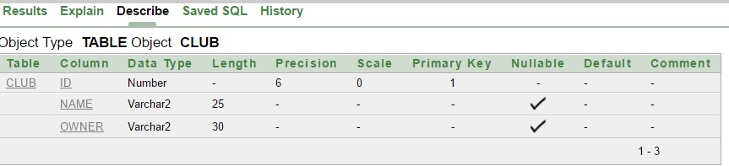

**Sponsor:**

Desc sponsor;

**14**

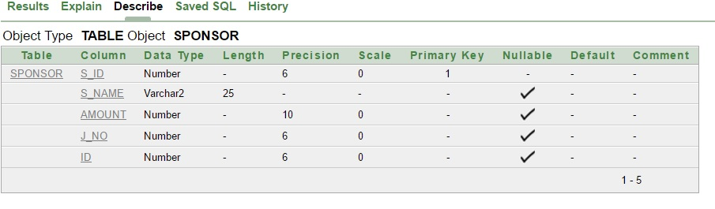

**Joursey:**

Desc joursey;

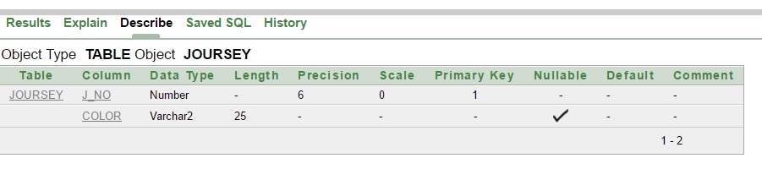

**Player:**

Desc player;

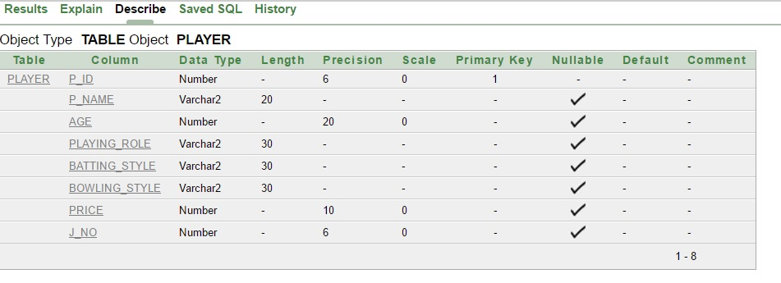

**Stadium: 15**

Desc stadium;

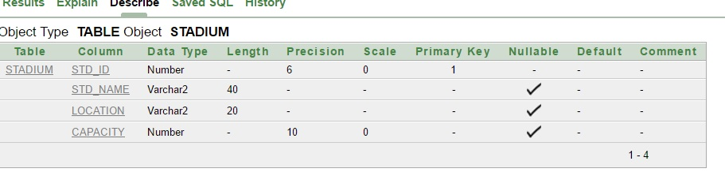

**Match:**

Desc match;

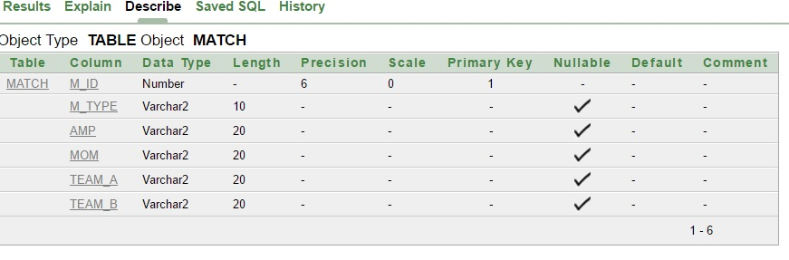

**Match_summary:**

Desc match_summary;

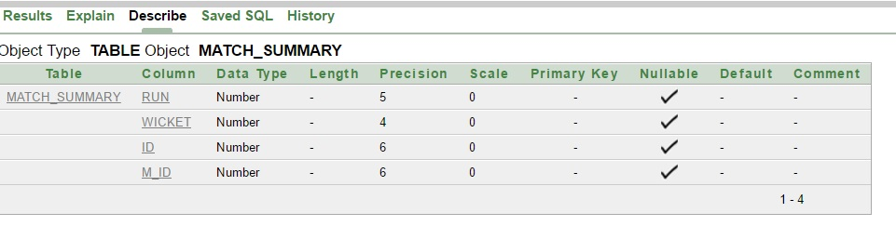

**Vanue_details: 16**

Desc vanue_details;

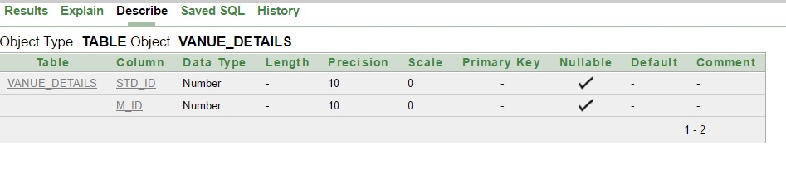

**Table with data (Screenshot)**

**Club:**

Select * from club;

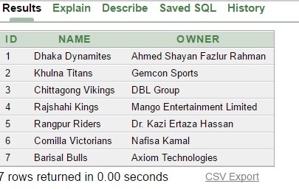

**17**

**Sponsor:**

Select * from sponsor;

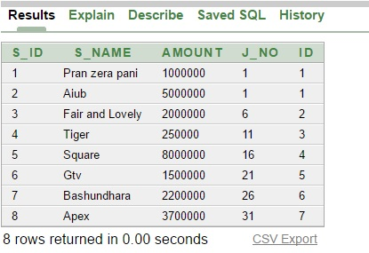

**18**

**Joursey:**

Select * from joursey;

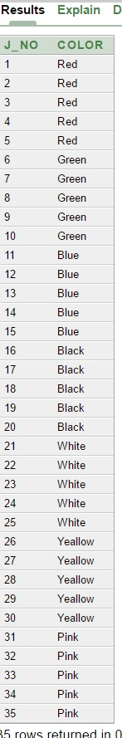

**19**

**Player:**

Select * from player;

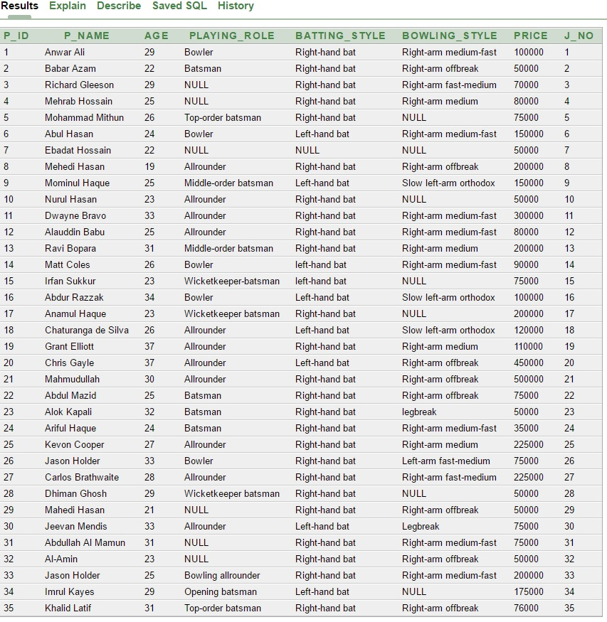

**20**

**Stadium:**

Select * from stadium;

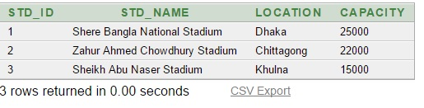

**Match:**

Select * from match;

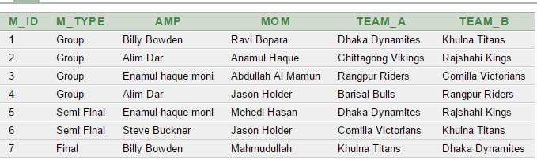

**21**

**Match_summary:**

Select * from match_summary

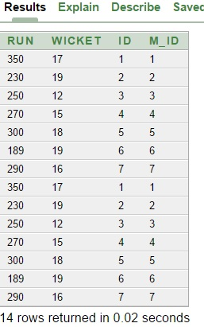

**Vanue_details:**

Select * from vanue_details;

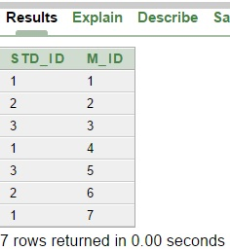

**22** **User Questionnaire & SQL queries based on that**

1. Display the highest, lowest, and average price of the players.

**Ans:** select min(price), max(price), avg(price) from player;

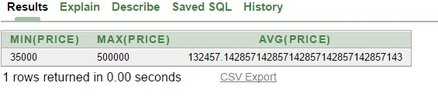

2. Display the club Id and minimum Sponsored amount for each club id, for all club id whose minimum amount is greater than 5000000.

**Ans:** select id, min(amount) from sponsor group by id having min(amount)>5000000;

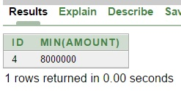

3. Display Id, Name, age, batting style for each player who are right handed batsman.

**Ans:** select p_id, p_name, age, batting_style from player where batting_style='Right-hand bat';

**23**

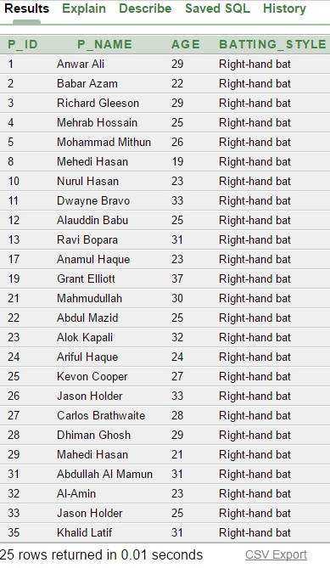

4. Display the match id whose stadium capacity is greater than 230000.

**Ans:** select m_id from vanue_details where std_id=(select std_id from stadium where capacity>23000);

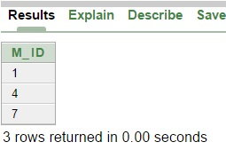

5. Display the player name age and batting style whose joursey color is green.

**Ans:** select p_name, age, batting_style from player where j_no in (select j_no from joursey where color='Green');

**24**

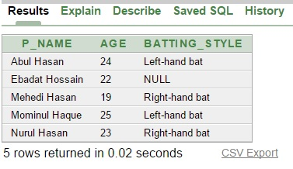

6. Display the teams whose run is greater than 300.

**Ans:** select team_a, team_b from match where m_id in (select m_id from match_summary where run>300);

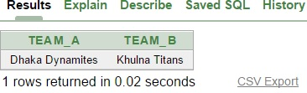

7. Display the name and owner of the club where in a match team a=Khulna titans.

**Ans:** select name, owner from club where id in (select id from match_summary where m_id=(select m_id from match where team_a='Khulna Titans'));

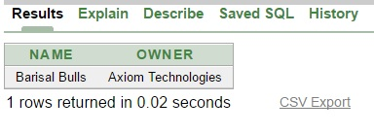

8. Display the player name, age and playing role for those players whose bowling style is 'Right-arm medium-fast.

**Ans:** select p_name, age, playing_role from player where bowling_style='Right-arm medium-fast';

**25**

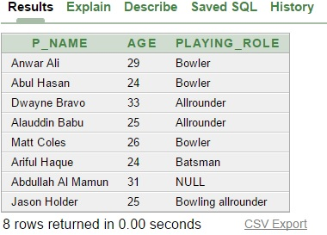

9. Display match type and man of the match where umpire is Billy Bowden.

**Ans:** select m_type, mom from match where amp='Billy Bowden';

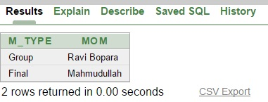

10. Display maximum run and minimum wicket for each id.

**Ans:** select max(run), min(wicket) from match_summary group by id;

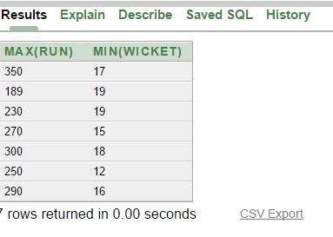

**26**

**Views**

**Simple View:**

* create view club_name as (select name from club);
* select * from club_name;
* create view player_info as (select p_name, age, batting_style, bowling_style, price from player);
* select * from player_info;
* create view std_info as (select std_name, location, capacity from stadium);
* select * from std_info;

**Complex View:**

* create view club_info as (select name, owner from club where id in(select id from match_summary where m_id=(select m_id from match where team_b='Comilla Victorians')));
* select * from club_info;
* create view club_sponsor as (select c.name, s.s_name from club c, sponsor s where c.id=s.id and s.s_name='Apex');
* select * from club_sponsor;